**  
"Mr. BookShare"  
Chapter One  
Introduction**

* 1. **Introduction**

E-learning systems have been increasingly popular among educators after the World Health Organization designated COVID-19 a global epidemic. Al-Araini Distance education is being accepted at an unprecedented rate in the sphere of higher education throughout the world, bypassing hurdles, issues, and difficulties, according to the report.

A series of scientific and technical advancements have placed new expectations on higher education institutions in recent years. This is although these institutions have limited skills and resources, and they must modernize to meet the rising demand for higher education. [1]

Higher education institutions must make use of technological advances to make their curriculum available to students at any time and from any location. Sabah to keep up with scientific advances, higher education must undergo several transformations. The biggest ones are a shift away from rigidity and toward a more flexible approach, as well as a shift from minimal standards to mastery and excellence. [1]

The idea of ​​exchanging books and academic aid began as an individual activity in universities, and then developed into a service through which the student aims to publish his current academic assistance or obtain it from other students; As this activity helps in increasing social relations between students, and on the other hand, it has contributed to easing the financial burden on most of them.

Interactive activity plays an important role in the social, economic and academic growth of students in universities.

As this academic support contributes to raising the academic and scientific achievement of the students, the educational materials and academic content are transferred to achieve the highest levels of knowledge and understanding.

This traditional activity has turned into electronic work (using social networking sites) as a result of technological progress and the special circumstances that govern it.

Computers or other electronic devices are used to generate, publish, and read electronic books (also known as E-Books). have a printed book that corresponds to it; You can read e-books on mobile phones and laptops if you don't have access to a computer or a device designed to reading e-books called an e-book reader [2].

There are some qualities that e-books share [2]:

1. It is easy to transfer and upload to other devices.
2. Computer-based access to its material.
3. Imagery, video clips, animations, sound effects, and more are all included.
4. When using a computer or other gadgets, it is easy to read.
5. When the quotations are linked to the original scientific references, the original reference may be opened, allowing the quotation to be seen as it was written by the author.
6. View the e-book with pens and comments.
7. Using an LCD display device or a wall projector, it may be shown to pupils in the classroom.
   1. **Background**

Cross-Platform apps have many components without which the app will not be able to function, such as: [3]

* + - 1. **Activities:** Activities are a type of class that is used as a user's entry point and represents a single screen. For example, a messaging application may contain activities that show fresh notifications, another activity that reads messages, and yet another that composes messages.
      2. **Services:** In other words, it's an unseen worker for our application. It is constantly updating the data sources and actions that are being tracked. Aside from doing tasks while apps aren't running, it may also broadcast intents. Using the internet or any other application while listening to music is an example of a service.
      3. **Content Providers:** Applications can communicate data using the Content Provider component. Because it masks the database's details, it may be used to read and write the application's confidential data. Data from other apps would be impossible to access without content providers.
      4. **Broadcast Receiver:** When another application or system broadcasts a message, the Broadcast Receiver component reacts. Even applications that are not operating can receive broadcasts. Notify the user, for example, that the battery is running low. Flutter developers may utilize broadcast messages within the application or outside of the usual flow to communicate with other Flutter developers and users.
  1. **Project Objectives**

Our project aims primarily to provide a process of sharing and exchanging academic endeavors among the students of Yarmouk University in a unique and different way from the previous experiences of the students.

The project objectives can be summarized through the following points:

1. Strengthening the spirit of cooperation among university students.
2. Promoting the principle and concept of reuse.
3. Preserving the largest amount of environmental nutrients by reducing the use of paper.
4. Helping students who are unable to pay for books by providing almost new and usable copies.
   1. **Motivation**

The inspiration for this project came from the difficulties some university students face in accessing academic aid. As a result, we have built this project so that it is intended for students of Yarmouk University so that they can obtain the required academic support from other students; which helps in raising the spirit of cooperation and intimacy among students.

* 1. **Project Aim**
     1. **Project Scope**

The application has been developed to include students of Yarmouk University, in order to create a means that allows them to communicate with each other and exchange scientific material and academic support within a specific geographical location (Yarmouk University).

* + 1. **Project Goal**

To ease the process of exchanging books and academic aids among students at Yarmouk University, students have access to an application that creates a distinctive place and a unique experience in the realm of digital (electronic) libraries.

* 1. **Project Description**

When the application is opened for the first time, the application is downloaded through the setup screen (splash screen), then the user is taken to the login screen (login screen) to log in by registering his email and password. In the absence of an account, the user enters the registration screen (registration screen) to enter his personal data (name, phone number, email, and password) to create his own account on the application and enter the main interface (the main screen).

If the user has previously registered and saved the login process, he will go to the main interface (the main screen) to choose a college and then choose the department of this college to see all the publications of that particular department to add them to the favorites list or contact the author of the publication via email.

In the event that the user wants to add a publication, he can press the add button to show him a small screen (Pop Message) to fill in the required data such as (the name of the material, the name of the doctor, and the name of the file); If he wants to view his favorites, he can do so by clicking on the favorites from the side menu (side menu) to show him a list of all the posts he added previously; He can also change his account picture, and he can also log out of the app!

* 1. **System Requirements**

It is a study to determine the goals and actions effectively. It is also a problem-solving technology that divides the system into parts to examine the success of these parts and interact to achieve the desired goal. System analysis relates to requirements analysis, Figure (1.1).

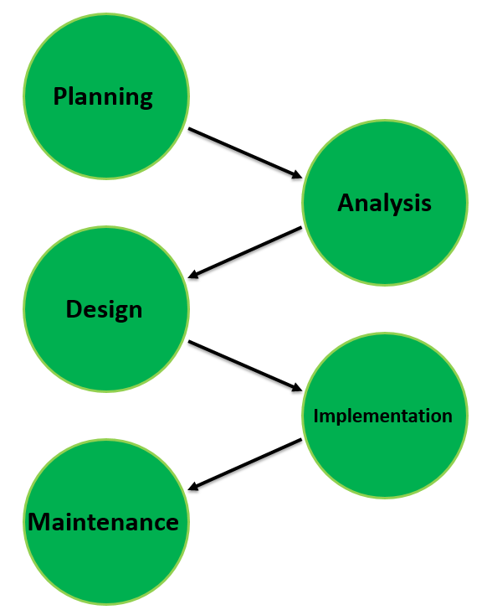

Figure 1.1: System Development Life Cycle (SDLC).

* + 1. **User requirements**
       1. **Functional requirements**

Actors in the application of Mr. BookShare:

* **User:**

1. The User shall be able to create an account with his personal information.
2. The User shall be able to login into the application by Email, password.
3. The User can set a profile picture.
4. The User shall be able to insert the information of the post.
5. The User shall be able to contact other users.
6. The User shall be able to add any post to Favorite.
   * + 1. **Non-functional requirements**

* **Availability:** The application’s availability success rate shall be 100%.

The application shall be available 24h/7d.

* **Performance:** The application shall take an advantage of concurrency which makes the application run faster.
* **Security:** The application shall be password protected.

The cloud shall be able to authenticate the clients by using the authentication server.

* **Modifiability:** The application’s components shall be able to be changed without breaking the whole application.
* **Usability:** The application's user interface shall be intuitive.

The application’s user interface shall use easy-to-read fonts.

* **Scalability:** The application shall be able to enlarge in features and handles an increasing amount of workload.
  + 1. **System Requirements**

System requirements are the configuration that a system must-have for a hardware or software application to run smoothly and efficiently. Failure to meet these requirements can result in installation problems or performance problems. The former may prevent a device or application from getting installed, whereas the latter may cause a product to malfunction or perform below expectation, or even hang or crash.

* **Hardware Requirements**

The most common set of requirements defined by any operating system or software application is the physical computer resources, also known as hardware, it's shown in Table (1.7.2.1).

|  |  |
| --- | --- |
| Specification | Recommended Requirements |
| Computer Type | Lenovo (IdeaPad Gaming 3) |
| Computer CPU | Intel Core i7-11370H,  11th Generation |
| Computer RAM | 16GB DDR4 |
| Computer Storage | Internal 512GB |
| User Device | Android & IOS Devices Version 5.5 or up |

Table 1.7.2.1: Hardware Requirements.

* **Software Requirements**

The software requirements are a description of the features and functionalities of the target system. Requirements convey the expectations of users from the software product. The requirements can be obvious or hidden, known or unknown, expected or unexpected from a user’s point of view. Software requirements are defined as follows: The conditions or capabilities the user needs to solve a problem or achieve a specific goal.

Conditions or capabilities of the software to make it compatible with the capabilities of the system to verify the contract and the characteristics agreed upon between the developer and the user, and it's shown in Table (1.7.2.2).

|  |  |
| --- | --- |
| Specification | Recommended Requirements |
| Operating System | Windows 10 |
| Target Program | Android Studio |
| Program Language | Flutter (Dart) |

Table 1.7.2.2: Software Requirements.

* + 1. **Domain Requirements**

It is important because we really need a system to help university students search for academic aids, to reduce the effort and time they spend on research, and this system provides users with an integrated environment that includes all colleges, departments, and academic subjects to reach an easy and flexible process that is different from its predecessors.

By:

1. Choosing the student's college and department.
2. Determining the material required by the students or publishing it to help other students use the application interfaces.

Where the application will achieve more accurate and efficient services if the user can deal with the system efficiently.

**Reference:**

[1] Zohra Lassoued/ Mohammed Alhendawi/ Raed Bashitialshaaer, An Exploratory Study of the Obstacles for Achieving Quality in Distance Learning during the COVID-19 Pandemic, access date: 3/9/2020.  
URL: <https://www.mdpi.com/2227-7102/10/9/232>

[2] Wikipedia, Electronic Book, access date: 19/2/2021.  
URL: <https://en.wikipedia.org/wiki/Ebook>

[3] data-flair.training, Android Application Components with Implementation & Examples, access date: 15/8/2021.  
URL: <https://data-flair.training/blogs/android-application-components/>